



**Human Computer Interface**

Project Report

[Usability Report]

Student Id : 2227086

Student Name : Hemant Bam

Group : L5CG1

Module Leader : Dipesh Shrestha

Instructor : Abishek Sitaula

Cohort : 8

Submitted on : <>

# Introduction:

## Usability :

Usability is a product's capacity for being successfully used by a user to achieve a certain purpose. In order to make the user journey for the needed task easy, it must be designed in a way that the user can quickly access that product feature. With a strong usability design, user satisfaction will gradually rise since the work is easier to do, however with a poor usability design, customers may run into issues that may eventually lead them to switch to other products.

## Importance of usability in your field of study:

Usability is essential for eCommerce mobile apps since it has a direct impact on user happiness, conversion rates, and the entire user experience. Consumers today have high standards for the online purchasing experience. Usability is vital in an eCommerce mobile app for the following reasons:

* Better User Experience:

Users can locate what they're looking for more easily and make purchases more quickly and effectively when an app is well-designed.

* Retention of the Customer:

If an eCommerce mobile app is simple to use and navigate, consumers are more likely to use it again. The company can raise user retention rates and boost income by making the app more user-friendly.

* Advantage at Competitive:

An app's greater usability may bring in and keep users, giving it an advantage over competitive eCommerce applications.

In Summary, The usability of a mobile eCommerce app is crucial since it may improve user experience, encourage client retention, and provide a competitive edge.

# Literature Review:

## Study of the Usability Testing of E-Commerce Applications

### Review:

To accomplish objectives like usability, the application's flexibility, and controllability are the main aims of usability testing. E-commerce has modernized the purchasing experience, thus we must concentrate on methods to make e-commerce applications more usable. The researchers chose surveys as their study approach, and they also used internet tools to assess websites based on the Connectivity, Readability, Accessibility and Functional Performance four criteria.

Laboratory and remote usability testing are the two forms of usability testing that are conducted the most commonly.

* Laboratory Usability Testing – This method involves setting up a separate lab with a tester and observer. The observer serves as a quiet monitor and records the tester's actions.
* Remote usability testing - With this technique, the tester and observer are in different places. In this scenario, the tester completes the given job, which is recorded, and the findings are later examined by the observer.

From the documentation, According to user feedback, the three things that influence consumers the most when they purchase online are an easy application interface, good customer service, and a reliable application. It is also learned that compared to the e-commerce application's Brand Value, Exclusive Offers do not draw in the audience as much. From the research, it is also known that when an e-commerce app is simpler, better, and meets consumers' needs, it boosts the company's sales.

The application's bugs are also known to ruin shopping plans, which can result in revenue losses for businesses, yet three-quarters of users still use the same app since they are devoted to it. Also, the consumers expressed complaints about the unpleasant visualization of goods and services and low render quality, which was caused by out-of-date technology. Studies have shown that the inconsistent and incorrect use of widgets in apps has an impact on the usability and effectiveness of the program.

In conclusion, the research suggests that, In order to standardize the app and understand the possible Return on Investment, it has been suggested that suppliers pay more attention to the code development of apps in the very early phases. (Samkit & Pradnya, 2021)

## An Investigation into Usability Aspects of E-Commerce Websites Using Users’ Preferences

### Review:

One of the most crucial characteristics of any user interface is usability, which assesses how simple it is for a user to utilize the interface. Based on the stated usability issues, there are three different groups of usability evaluation approaches. The methods are the User testing method, Heuristic testing and Tool based testing method.

* User testing method:

The user testing approach contains a collection of criteria that uses a variety of users to identify a variety of usability issues. It tries to measure user performance using a variety of user observation and satisfaction techniques.

* Heuristic testing:

A small group of evaluators will examine the interface while applying accepted usability principles (the "heuristics").

* Tool-based testing:

Using numerous software tools to identify various usability issues is known as tool-based testing.

This study's primary goal is to identify the design elements that have the greatest an impact on e-commerce sites' usability. This study is based on consumer impressions and preferences of many well-known e-commerce websites.

The majority of e-commerce websites studied had strengths in the areas of navigation, design, and content, while having weaknesses in the areas of consumer engagement, such as contact us and FAQs. It also recommends that the key elements for a better website are easy-to-use search capabilities, customer support, and assistance features, secure sites, site support, and personalization/customization. The results of this study indicated that the structural feature is the least significant feature that influences other elements of the usability of e-commerce websites, but consumers rank ease of use as the next feature that is employed in developing e-commerce websites. The results indicate that these two qualities have less of an impact on developing e-commerce websites, but they—along with their sub-features—must be taken into consideration when designing or assessing the usability of e-commerce websites.

The present study includes two restrictions: The 10 e-commerce websites were evaluated using a questionnaire alone, without the use of heuristic testing or tool-based testing, which is the first limitation. The second limitation relates to the number of clicks, which may affect the results when evaluating the usability of e-commerce websites. (Sandeep, et al., 2015)

## Products related to field of study:

1. Goldstar Shoes <https://play.google.com/store/apps/details?id=com.goldstarshoes&hl=en&gl=US>
2. Caliber Shoes

<https://play.google.com/store/apps/details?id=com.calibershoes&hl=en&gl=US>

# Analysis:

## Goldstar Shoes:

Figure 2 Goldstar

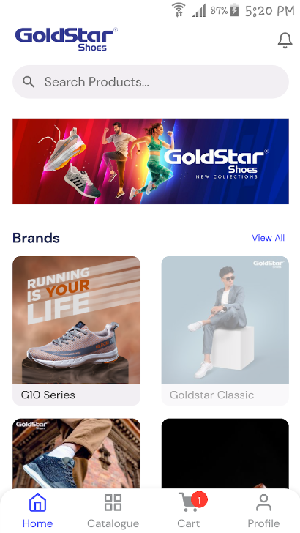

Figure 1 Goldstar

|  |  |
| --- | --- |
| Applied Rules |  |